Molecular Formula: NdH_{2~3}
Purity:99.5%
Specification:- 100 mesh / - 200 mesh
CAS:13864-04-5
EINECS No.:237-610-3

Neodymium hydride (NdH_{2~3})-Powder

Characteristic
Neodymium hydride is an inorganic compound composed of neodymium and hydrogen with a chemical formula NdH₃. It is considered as the most common hydride of neodymium. In this compound, the neodymium atom is in the +3 oxidation state and the hydrogen atoms are -1. It is highly reactive Neodymium hydride is a blue crystal of the hexagonal system, with unit cell parameters a=0.385 nm, c=0.688 nm. It reacts with water to form neodymium hydroxide and hydrogen gas.

Appearance：Powder
Molecular Weight：147.27 g/mol
Density：N/A

Chemical Composition

Rare Earth Impurity(≤) |  |  |  | Nd/RE |  | ≥99.5%
Item | La/RE | Ce/RE | Pr/RE | Sm/RE | Y/RE
Content(%) | 0.012 | 0.020 | 0.020 | 0.010 | 0.001
Non-Rare Earth Impurity(≤) |  |  |  | RE |  | ≥99%
Item | Fe | Si | Ca | Mg | Al | C | Mo
Content(%) | 0.241 | 0.010 | 0.010 | 0.010 | 0.010 | 0.039 | 0.033

Granularity of materials- 200 mesh
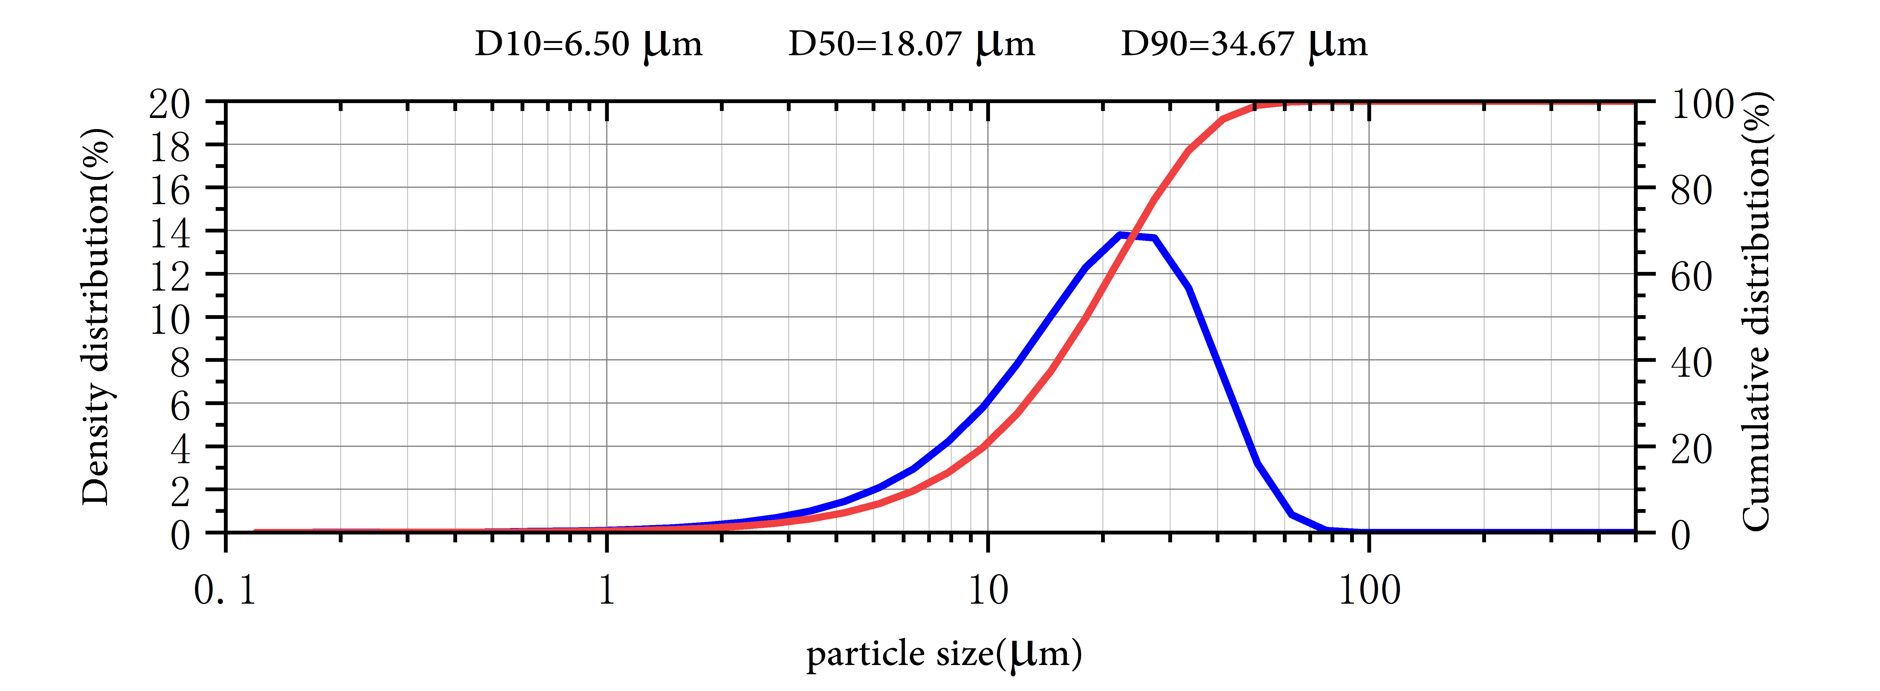

Application
A important use of neodymium hydride is as a component in the alloys used to make high-strength neodymium magnets-powerful permanent magnets.
Adding neodymium to magnesium or aluminum alloy can improve the high temperature performance, air tightness and corrosion resistance of the alloy, and is widely used as an aerospace material.

Package:
Vacuum pumping and argon protection, 500g or 1000g / bottle

