Molecular Formula: Tb
Purity:99.9%
Specification:- 100 mesh / - 200 mesh
CAS:7440-27-9
EINECS No.:231-137-6

Terbium Metal (Tb)-Powder

Characteristic

Terbium is a chemical element with the symbol Tb and atomic number 65. It is a silvery-white, rare earth metal that is malleable, and ductile. The ninth member of the lanthanide series, terbium is a fairly electropositive metal that reacts with water, evolving hydrogen gas. Terbium is never found in nature as a free element, but it is contained in many minerals, including cerite, gadolinite, monazite, xenotime and euxenite.

Appearance：Powder
Melting point：1629 K (1356 °C, 2473 °F)
Boiling point：3396 K (3123 °C, 5653 °F)
Density (near r.t.)：8.23 g/cm3
when liquid (at m.p.)：7.65 g/cm3
Heat of fusion：10.15 kJ/mol
Heat of vaporization：391 kJ/mol
Molar heat capacity：28.91 J/(mol·K)

Chemical Composition

Rare Earth Impurity(≤) |  |  |  | Tb/RE |  | ≥99.9%
Item | La/RE | Ce/RE | Pr/RE | Nd/RE | Sm/RE | Eu/RE | Gd/RE
Content(%) | 0.0002 | 0.0003 | 0.0002 | 0.0009 | 0.0001 | 0.0001 | 0.0011
Item | Dy/RE | Ho/RE | Er/RE | Tm/RE | Yb/RE | Lu/RE | Y/RE
Content(%) | 0.0011 | 0.0001 | 0.0001 | 0.0001 | 0.0001 | 0.0001 | 0.0005
Non-Rare Earth Impurity(≤) |  |  |  | RE |  | ≥99%
Item | Al | Fe | Ca | Si | Mg | C | O
Content(%) | 0.0270 | 0.0260 | 0.0280 | 0.0240 | 0.0210 | 0.0150 | 0.1400

Granularity of materials - 200 mesh
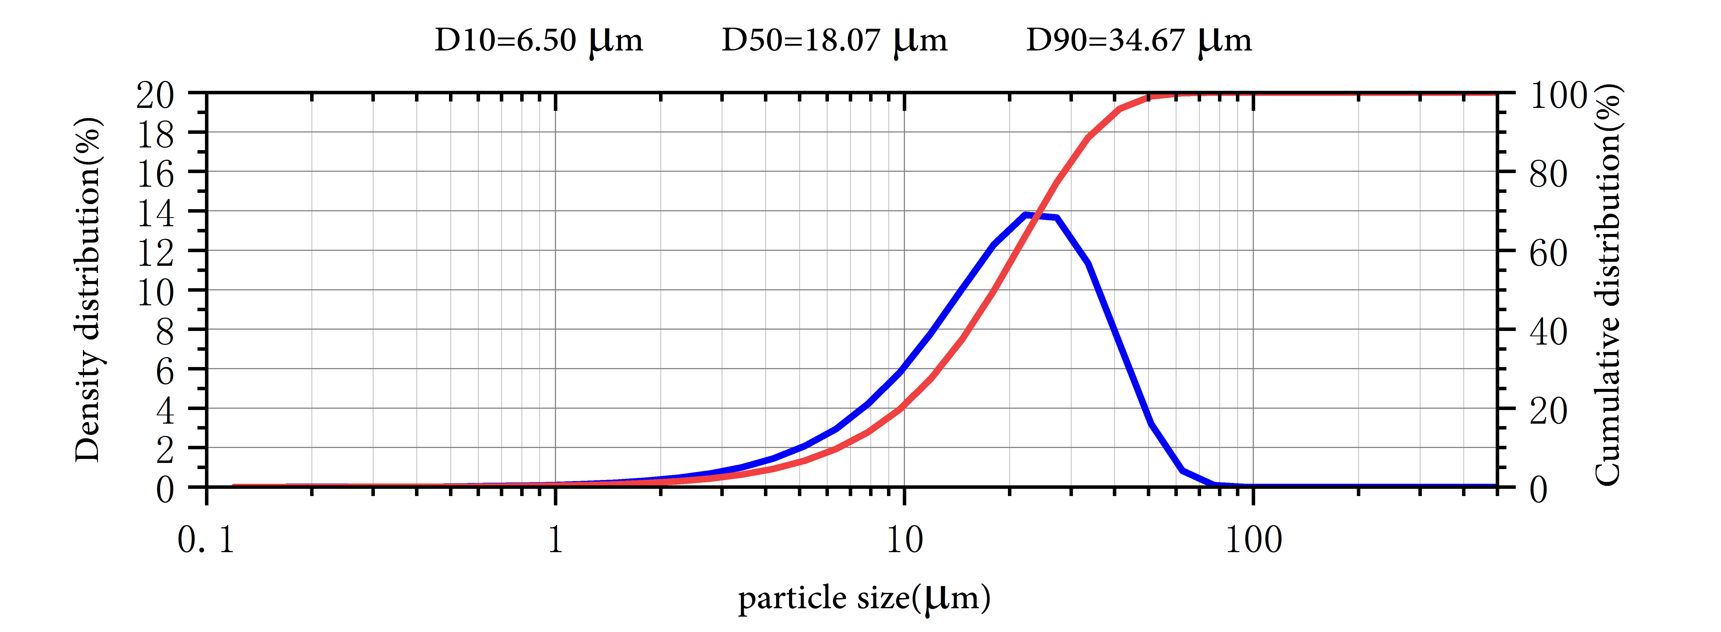

Application

Terbium is used to dope calcium fluoride, calcium tungstate and strontium molybdate, all used in solid-state devices. It is also used in low-energy lightbulbs and mercury lamps. It has been used to improve the safety of medical x-rays by allowing the same quality image to be produced with a much shorter exposure time. Terbium salts are used in laser devices.
An alloy of terbium, dysprosium and iron lengthens and shortens in a magnetic field. This effect forms the basis of loudspeakers that sit on a flat surface, such as a window pane, which then acts as the speaker.

Package:
Vacuum pumping and argon protection, 500g or 1000g / bottle

