Molecular Formula: SmB₆
Purity:99.9%
Specification:- 360 mesh / - 500 mesh
CAS:12008-30-9
EINECS No.:234-529-5

Samarium Boride (SmB₆)-Powder

Characteristic
Samarium Boride, also called Samarium Hexaboride, is one of the rare earth borides, the molecular formula is SmB₆. SmB₆ is an intermediate-valence compound where samarium is present both as Sm²⁺ and Sm³⁺ ions at the ratio 3:7. It belongs to a class of Kondo insulators.
At temperatures above 50 K its properties are typical of a Kondo metal, with metallic electrical conductivity characterized by strong electron scattering, whereas at low temperatures, it behaves as a non-magnetic insulator with a narrow band gap of about 4–14 meV.
The cooling-induced metal-insulator transition in SmB₆ is accompanied by a sharp increase in thermal conductivity, peaking at about 15 K. The reason for this increase is that electrons do not contribute to thermal conductivity at low temperatures, which is instead dominated by phonons. The decrease in electron concentration reduced the rate of electron-phonon scattering.
Samarium Boride, also called Samarium Hexaboride, is one of the rare earth borides, the molecular formula is SmB6.

Molar mass：215.26 g/mol
Density： 5.07 g/cm³
Melting point： 2400 °C
Solubility in water：Insoluble
Crystal structure：Cubic

Chemical Composition
 | Major constituent |  | Impurity(≤)
Item | B | Sm | Fe | C | Mg | Si | Ca | Mn | Cu | Cr
Content(%) | 29.25 | 70.37 | 0.032 | 0.045 | 0.00037 | 0.0035 | 0.0083 | 0.00037 | 0.0007 | 0.0005

Granularity of materials -360 mesh

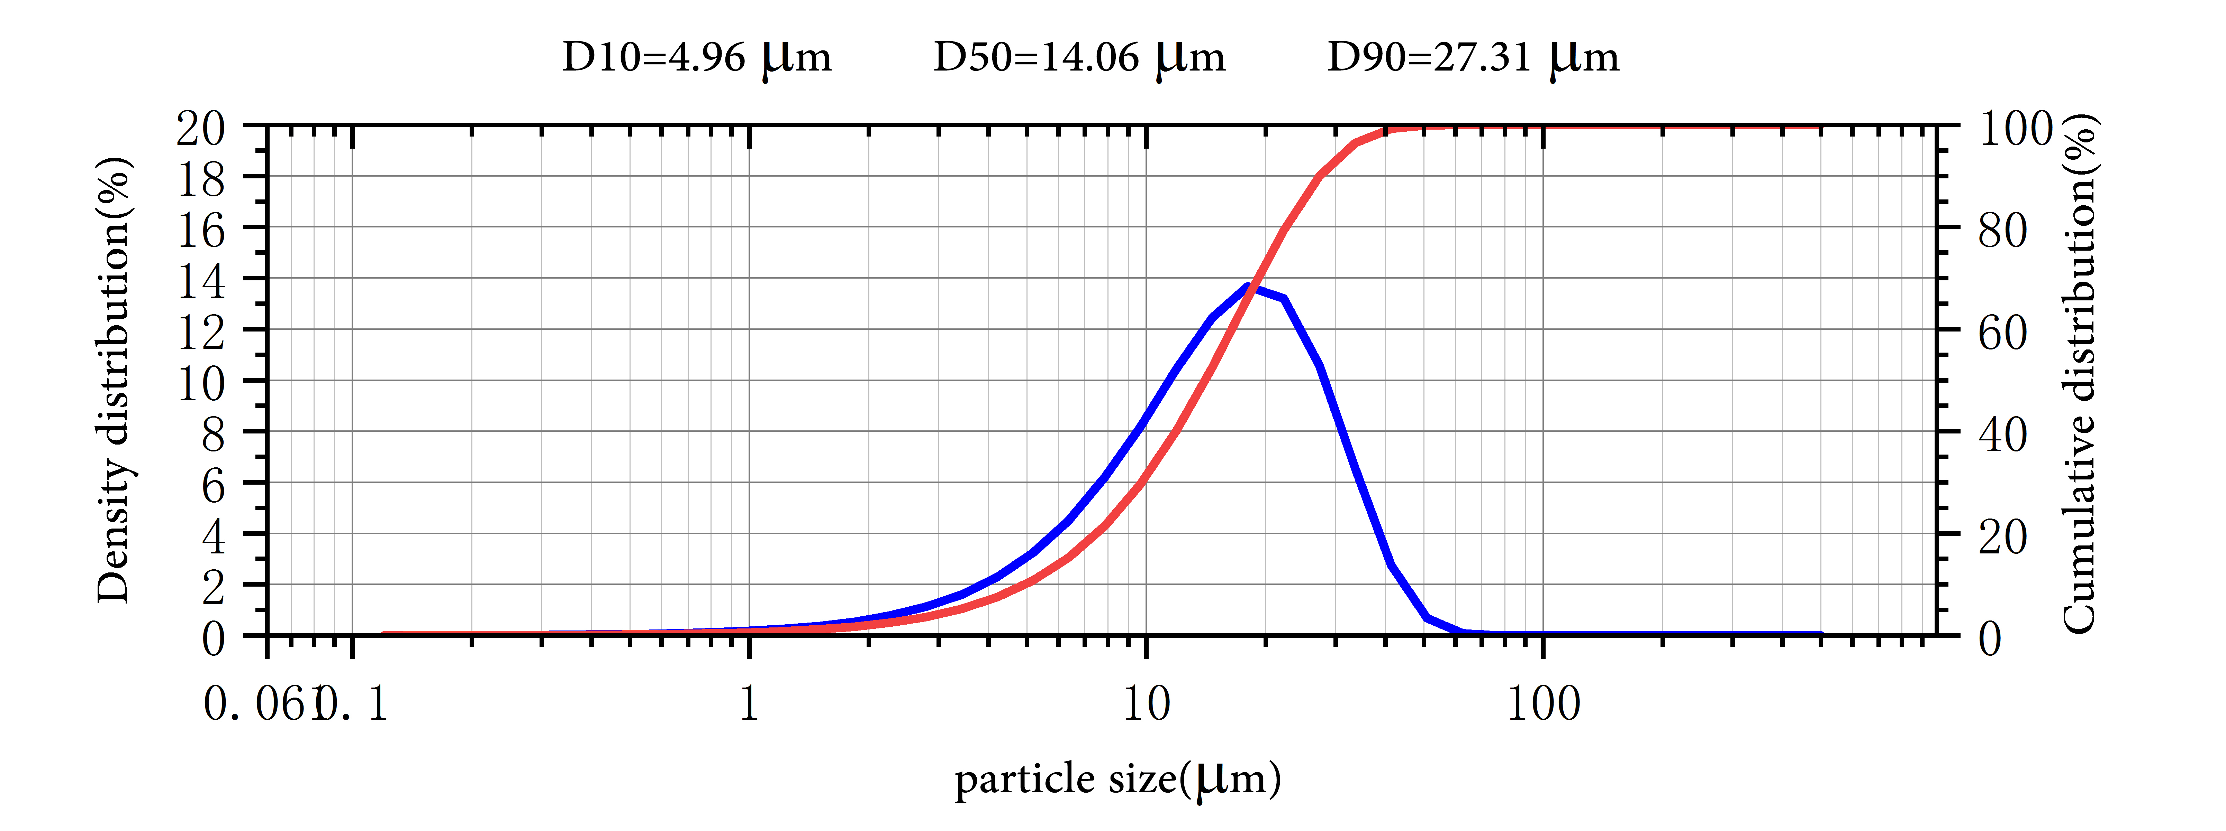
Application

Samarium Boride (SmB6) is classified in the groups of materials of superior properties attracting the attention of many scientist and technologist recently. Its unique features such as high mechanical strength and thermal stabilities, low work function, high melting points, and low volatility at high temperatures make them potential candidates for the advanced technological applications. Its unique electromagnetic properties have been drawing continued interest for a variety of engineering applications.

Samarium Boride Synonyms
Samarium hexaboride

Package:
Vacuum pumping and argon protection, 500g or 1000g / bottle

