Molecular Formula:DyH_{2~3}
Purity:99.9%
Specification:- 100 mesh / - 200 mesh
CAS:13537-09-2
EINECS No.:236-900-7

Dysprosium hydride(DyH_{2~3})-Powder

Characteristic
Dysprosium hydride is a compound of hydrogen and dysprosium. It is considered to be a part of the class of rare-earth metal hydrides. Metal hydrides are very attractive and important materials in the permanent magnets field. Dysprosium is a chemical element with the symbol Dy and atomic number 66. It is a rare earth element with a metallic silver luster. As-cast dark gray powder is extremely susceptible to oxidation and ignition in the air.

Appearance：Powder
Molecular Weight：165.52 g/mol
Density：N/A

Chemical Composition
Rare Earth Impurity(≤) |  |  |  | Dy/RE |  | ≥99.9%
Item | La/RE | Ce/RE | Pr/RE | Nd/RE | Sm/RE | Eu/RE | Gd/RE
Content(%) | 0.0028 | 0.0005 | 0.0002 | 0.0013 | 0.0004 | 0.0001 | 0.0006
Item | Tb/RE | Ho/RE | Er/RE | Tm/RE | Yb/RE | Lu/RE | Y/RE
Content(%) | 0.0024 | 0.0053 | 0.0046 | 0.0004 | 0.0022 | 0.0054 | 0.0445
Non-Rare Earth Impurity(≤) |  |  |  | RE |  | ≥99%
Item | Al | Fe | Ca | Si | Mg | C | O
Content(%) | 0.0056 | 0.0067 | 0.0075 | 0.0340 | 0.0011 | 0.0190 | 0.0041

Granularity of materials - 200 mesh

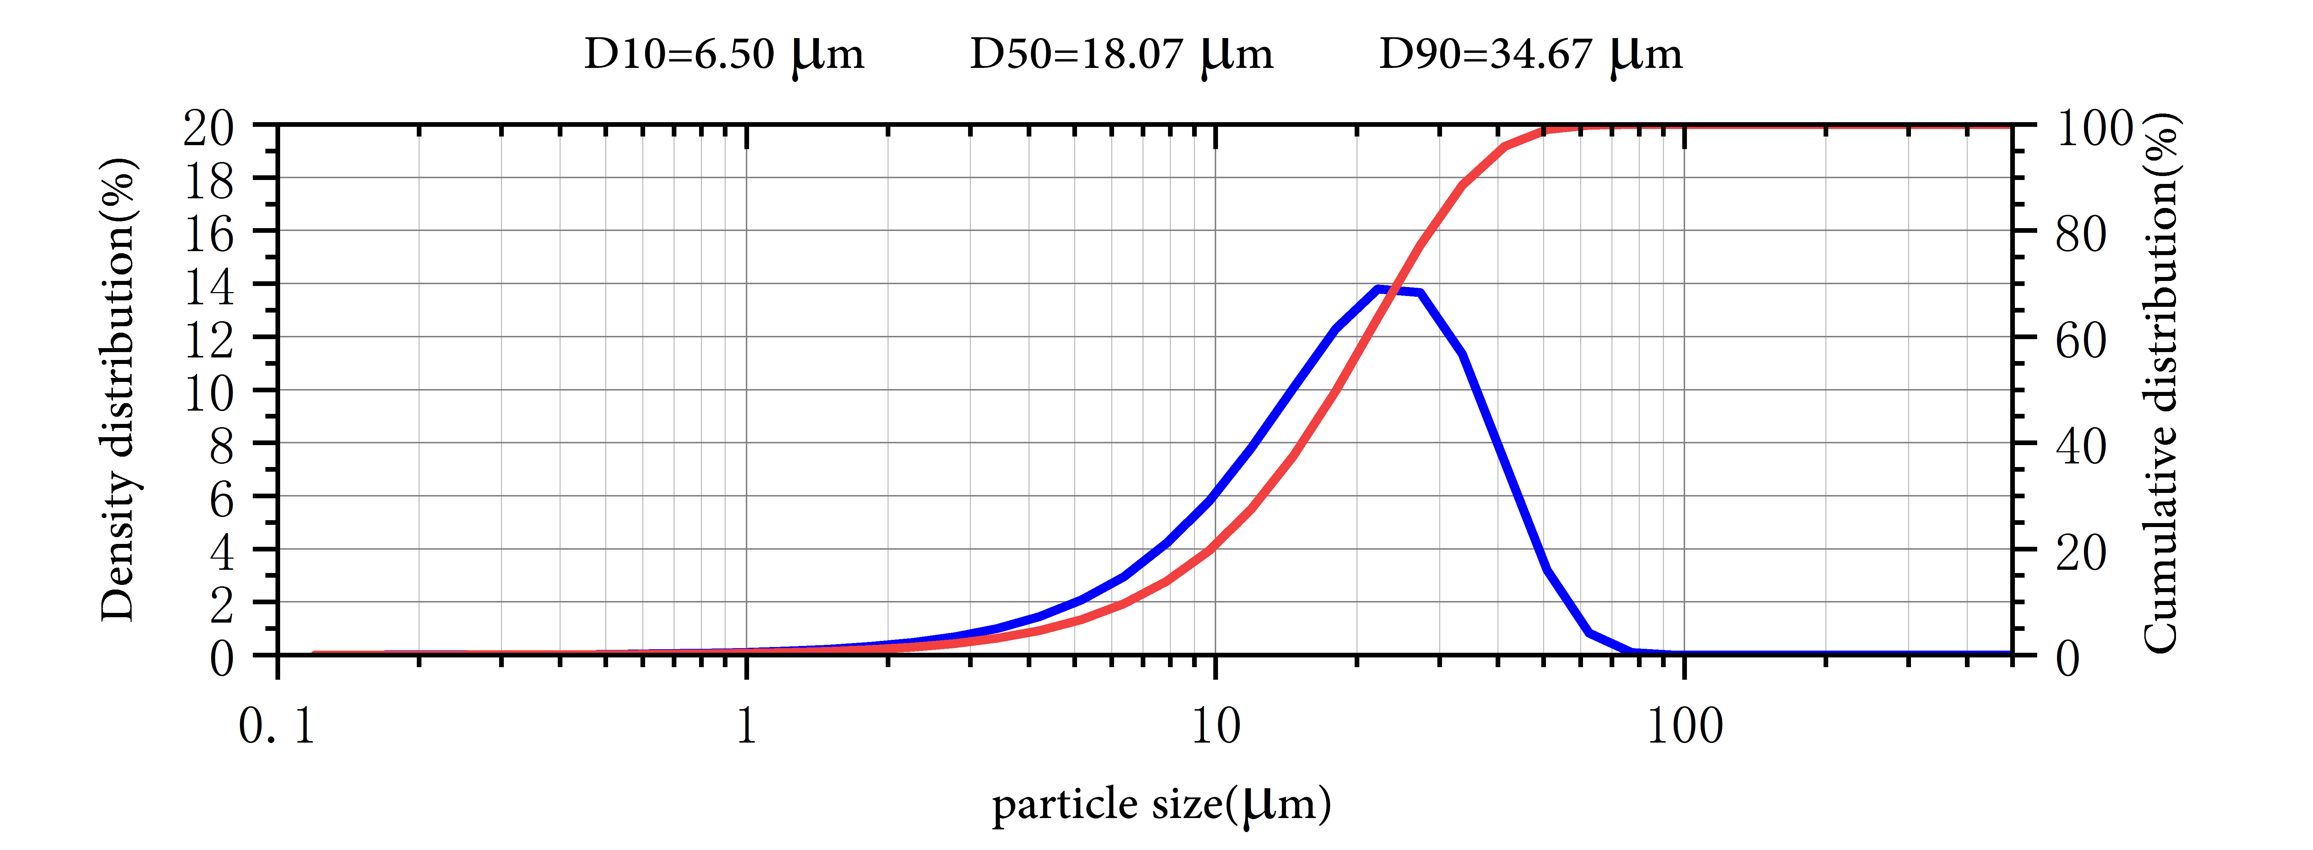
Application
Dysprosium hydride is an important additive for NdFeB permanent magnets to raise the Curie temperature and improve temperature coefficiency. It is highly susceptible to magnetization, they are employed in various data-storage applications, such as in hard disks.
Dysprosium hydride is used in the preparation of hydrogen storage alloys, catalysts, etc. in special fields such as aerospace, special metals and electronic lasers.

Package:
Vacuum pumping and argon protection, 500g or 1000g / bottle

