Molecular Formula: TbH_{2~3}
Purity:99.9%
Specification:- 200 mesh / -100mesh/ - 5µm
CAS:13598-54-4
EINECS No.:237-071-4

Terbium hydride(TbH_{2~3})-Powder

Characteristic
Terbium hydride is a compound of hydrogen and terbium. It is considered to be a part of the class of rare-earth metal hydrides. Metal hydrides are very attractive and important materials in the permanent magnets field. Terbium is a chemical element with the symbol Tb and atomic number 65. It is a silvery-white, rare earth metal that is malleable, ductile, and soft enough to be cut with a knife. Terbium is highly reactive. It should be stored in a container filled with inert gas or a vacuum container.
Appearance：Powder
Molecular Weight：161.95 g/mol
Density：N/A

Chemical Composition

Rare Earth Impurity(≤) |  |  |  | Tb/RE |  | ≥99.9%
Item | La/RE | Ce/RE | Pr/RE | Nd/RE | Sm/RE | Eu/RE | Gd/RE
Content(%) | 0.0002 | 0.0003 | 0.0002 | 0.0009 | 0.0001 | 0.0001 | 0.0011
Item | Dy/RE | Ho/RE | Er/RE | Tm/RE | Yb/RE | Lu/RE | Y/RE
Content(%) | 0.0011 | 0.0001 | 0.0001 | 0.0001 | 0.0001 | 0.0001 | 0.0005
Non-Rare Earth Impurity(≤) |  |  |  | RE |  | ≥99%
Item | Al | Fe | Ca | Si | Mg | C | O
Content(%) | 0.0270 | 0.0260 | 0.0280 | 0.0240 | 0.0210 | 0.0150 | 0.1400

Granularity of materials - 200 mesh
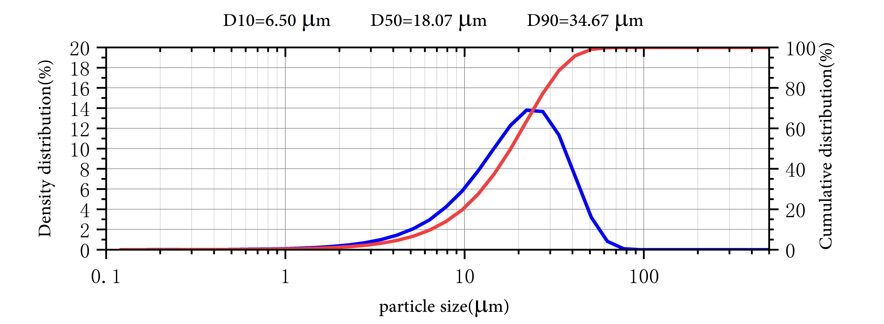

Application

Terbium hydride is the important additive for NdFeB permanent magnets to raise the Curie temperature and improve temperature coefficiency.
Terbium hydride is used in the preparation of hydrogen storage alloys, catalysts, etc. in special fields such as aerospace, special metals and electronic lasers.

Package:
Vacuum pumping and argon protection, 500g or 1000g / bottle

