Molecular Formula: LaB₆
Purity: 99.5%
Specification:- 360 mesh / - 500 mesh
CAS:12008-02-5
EINECS No.:234-526-9

Cerium Boride (CeB₆)-Powder

Characteristic

Cerium Boride, also called Cerium Hexaboride or CeB₆, is a refractory ceramic material. The principal use of cerium hexaboride is a coating of hot cathodes, or hot cathodes made of cerium hexaboride crystals. It usually operates at temperature of 1450 °C.Cerium hexaboride, like lanthanum hexaboride, slowly evaporates during the cathode operation. In conditions where CeB₆ cathodes are operated under 1850 K, CeB₆ should maintain its optimum shape longer and therefore last longer. While the process is about 30% slower than with lanthanum boride, the cerium boride deposits are reported to be more difficult to remove.

Molar mass： 204.98 g/mol
Appearance： intense purple violet
Density： 4.87 g/cm³
Melting point： 2,2552 °C (4,310 °F; 2,650 K)
Solubility in water：insoluble
Crystal structure：Cubic

Chemical Composition
 | Major constituent |  | Impurity(≤)
Item | B | Ce | Fe | C | Mg | Si | Ca | Mn | Cu | Cr
Content(%) | 31.85 | 67.9 | 0.04 | 0.072 | 0.00012 | 0.0018 | 0.0075 | 0.00042 | 0.0006 | 0.0002

Granularity of materials -360 mesh

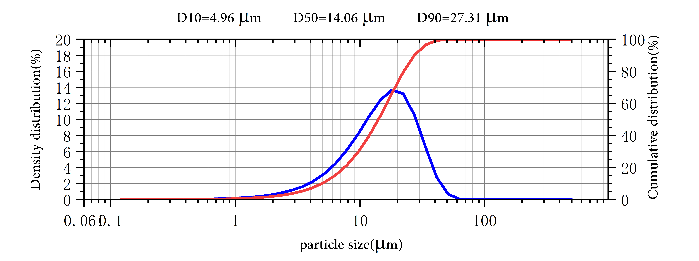
Application
Cerium boride cathodes show lower evaporation rate at 1700 K than lanthanum boride, but it becomes equal at 1850 K and higher above that. Cerium boride cathodes have one and half the lifetime of lanthanum boride, due to its higher resistance to carbon contamination. Boride cathodes are about ten times as "bright" than the tungsten ones and have 10–15 times longer lifetime. In some laboratory tests, CeB₆ has proven to be more resistant to the negative impact of carbon contamination than LaB₆. They are used e.g. in electron microscopes, microwave tubes, electron lithography, electron beam welding, X-Ray tubes, and free electron lasers.

Cerium Boride Synonyms
Cerium hexaboride, CeBix, CEBI

Package:
Vacuum pumping and argon protection, 500g or 1000g / bottle

