Molecular Formula: Ce
Purity: 99.5%
Specification:- 100 mesh / - 200 mesh
CAS:7440-45-1
EINECS No.:231-154-9

Cerium Metal (Ce)-Powder

Characteristic

Cerium is a chemical element with the symbol Ce and atomic number 58. Cerium is a soft, ductile, and silvery-white metal that tarnishes when exposed to air. Cerium is the second element in the lanthanide series, and while it often shows the +3 oxidation state characteristic of the series, it also has a stable +4 state that does not oxidize water. It is also considered one of the rare-earth elements. Cerium has no known biological role in humans but is not particularly toxic, except with intense or continued exposure.

Appearance：Powder
Melting point： 1068 K (795 °C, 1463 °F)
Boiling point： 3716 K (3443 °C, 6229 °F)
Density (near r.t.)： 6.770 g/cm³
when liquid (at m.p.)： 6.55 g/cm³
Heat of fusion： 5.46 kJ/mol
Heat of vaporization： 398 kJ/mol
Molar heat capacity： 26.94 J/(mol·K)

Chemical Composition
Rare Earth Impurity(≤) |  |  | Ce/RE |  | ≥99.5%
Item | La/RE | Pr/RE | Nd/RE | Sm/RE | Y/RE
Content(%) | 0.052 | 0.074 | 0.017 | 0.010 | 0.010
Non-Rare Earth Impurity(≤) |  |  | RE |  | ≥99%
Item | Fe | Si | Ca | Mg | Al | C
Content(%) | 0.087 | 0.026 | 0.012 | 0.018 | 0.013 | 0.027

Granularity of materials - 200 mesh
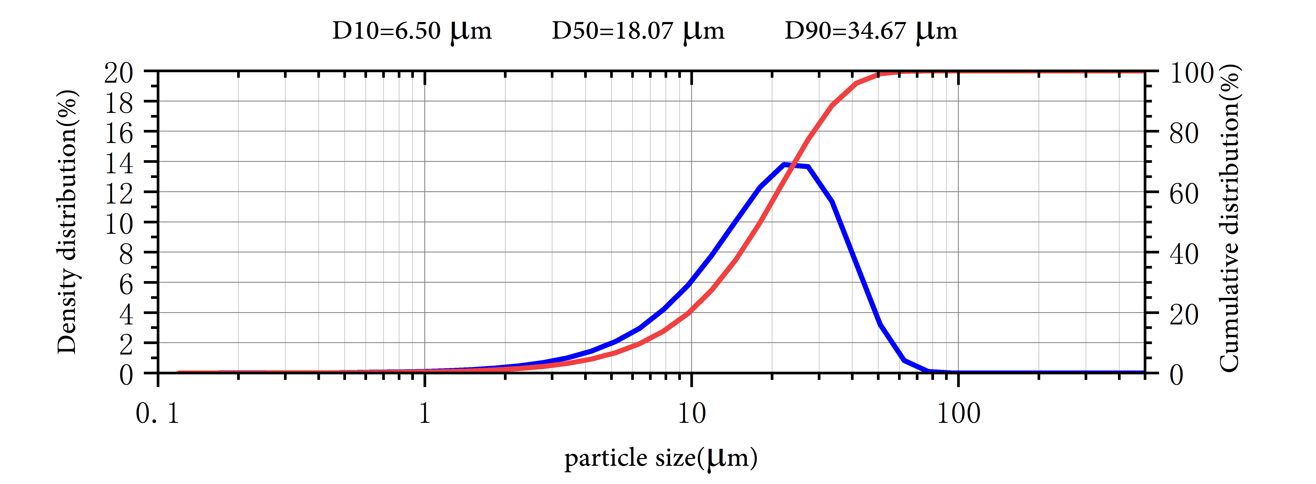

Application
Cerium is the major component of mischmetal alloy (just under 50%). The best-known use for this alloy is in ‘flints’ for cigarette lighters. This is because cerium will make sparks when struck. The only other element that does this is iron.

Cerium(Ill) oxide has uses as a catalyst. It is used in the inside walls of self-cleaning ovens to prevent the build-up of cooking residues. It is also used in catalytic converters. Cerium(III) oxide nanoparticles are being studied as an additive for diesel fuel to help it burn more completely and reduce exhaust emissions.
Cerium sulfide is a non-toxic compound that is a rich red colour. It is used as a pigment.
Cerium is also used in flat-screen TVs, low-energy light bulbs and floodlights.

Package:
Vacuum pumping and argon protection, 500g or 1000g / bottle

