Molecular Formula: EuB₆
Purity:99.9%
Specification:- 360 mesh / - 500 mesh
CAS:12008-05-8
EINECS No.:234-529-5

Europium Boride (EuB₆)-Powder

Characteristic

Europium Boride, also called Europium Hexaboride, is one of the rare earth borides, the molecular formula is EuB6. Its rigid crystal structure comprises cubical arrangements of metal atoms in a web of covalently bonded boron atoms. The unit cell can be described as a cube with boron octahedra occupying eight corners of the cube with a metal atom at the bodycenter position. The metallicity of EuB6 depends on the valence of the metal atom in EuB6. For a bivalent metal, EuB6 behave as non-metallic, and for trivalent metals, EuB6 show metallic property since the third electron of the metal goes to the conduction band contributing to the electrical property of EuB6. The valence electrons of boron are spread over five bonds creating electron vacancy. For each unit cell of EuB6, this situation produces two-hole states for every B6 group where each metal atom provides two electrons to fill the holes. These characteristics together with the strong bonds between the boron atoms in the crystal structure framework produce EuB6 that have electro-magnetic properties with high thermal stabilities

Molar mass： 216.83 g/mol
Solubility in water：insoluble
Crystal structure：Cubic

Chemical Composition
 | Major constituent |  | Impurity(≤)
Item | B | Eu | Fe | C | Mg | Si | Ca | Mn | Cu | Cr
Content(%) | 29.37 | 70.22 | 0.029 | 0.24 | 0.00019 | 0.0017 | 0.0076 | 0.00037 | 0.00050 | 0.0004

Granularity of materials -360 mesh
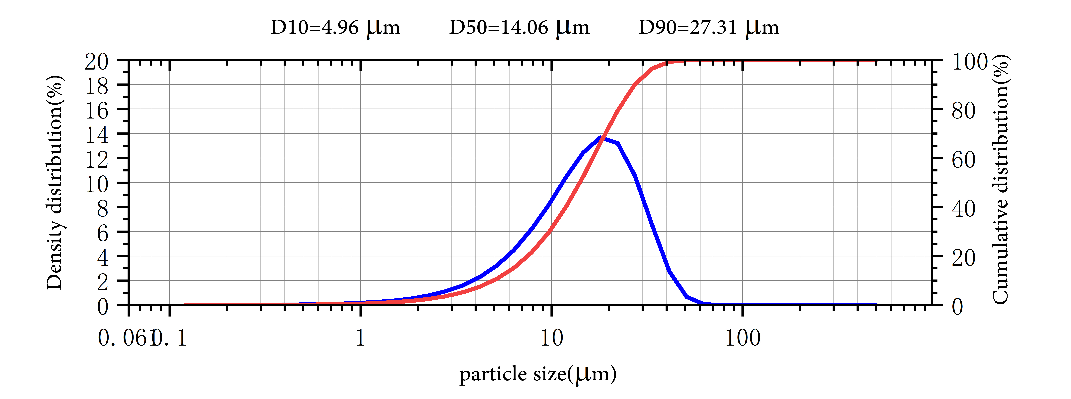

Application
Europium hexaboride (EuB6) is classified in the groups of materials of superior properties attracting the attention of many scientist and technologist recently. Its unique features such as high mechanical strength and thermal stabilities, low work function, high melting points, and low volatility at high temperatures make them potential candidates for the advanced technological applications. Its unique electromagnetic properties have been drawing continued interest for a variety of engineering applications.

Europium Boride Synonyms
Europium hexaboride; Europium, hexaborylidyne-

Package:
Vacuum pumping and argon protection, 500g or 1000g / bottle

