Molecular Formula: PrB₆
Purity: 99.5%
Specification:- 360 mesh / - 500 mesh
CAS:12008-27-4
EINECS No.:234-534-2

Praseodymium Boride (PrB₆)-Powder

Characteristic

Praseodymium Boride, also called Praseodymium Hexaboride, is one of the rare earth borides, the molecular formula is PrB6. The rare-earth hexaborides have the cubic CaB₆ structure , with rare-earth ions lying on a simple cubic lattice enclosing an octahedral B₆ cage. Praseodymium hexaboride PrB₆ and neodymium hexaboride NdB₆ are also antiferromagnetic metals in which the magnetic properties are treated as being governed by localized magnetic moments of rare earth ions that interact with each other through conduction electrons (the Ruderman–Kittel–Kasuya–Yosida mechanism). praseodymium hexaboride is believed to have a higher emission constant, and a lower volatility and congruent vaporization, which give rise to a lower operation temperature and longer service life comparing with conventional cathodic emission materials.

Molar mass： 205.77 g/mol
Solubility in water：insoluble
Crystal structure：Cubic

Chemical Composition
 | Major constituent |  | Impurity(≤)
Item | B | Pr | Fe | C | Mg | Si | Ca | Mn | Cu | Cr
Content(%) | 31.39 | 68.34 | 0.035 | 0.22 | 0.0009 | 0.0031 | 0.0078 | 0.00095 | 0.0011 | 0.00053

Granularity of materials -360 mesh
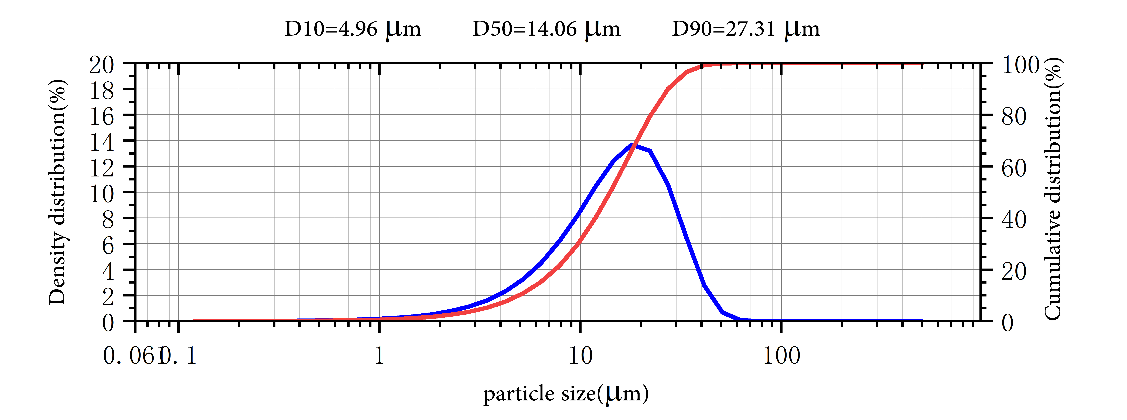

Application
Praseodymium hexaboride (PrB6) is classified in the groups of materials of superior properties attracting the attention of many scientist and technologist recently. Its unique features such as high mechanical strength and thermal stabilities, low work function, high melting points, and low volatility at high temperatures make them potential candidates for the advanced technological applications. Its unique electromagnetic properties have been drawing continued interest for a variety of engineering applications.

Praseodymium Boride Synonyms
Praseodymium hexaboride

Package:
Vacuum pumping and argon protection, 500g or 1000g / bottle

