Molecular Formula: GdH_{2~3}
Purity:99.9%
Specification:- 100 mesh / - 200 mesh
CAS:13572-97-9
EINECS No.:N/A

Gadolinium hydride (GdH_{2~3})-Powder

Characteristic
Gadolinium hydride is a compound of hydrogen and gadolinium. It is considered to be a part of the class of rare-earth metal hydrides. Gadolinium hydride shows salt-like behavior owing to the small electronegativity of gadolinium. Gadolinium is a chemical element with the symbol Gd and atomic number 64. Gadolinium is a silvery-white metal when oxidation is removed. It is only slightly malleable and is a ductile rare-earth element. Gadolinium reacts with atmospheric oxygen or moisture slowly to form a black coating.

Appearance：Powder
Molecular Weight：160.27 g/mol
Density：7.9 g/cm³

Chemical Composition

Rare Earth Impurity(≤) |  |  |  | Gd/RE |  | ≥99.9%
Item | La/RE | Ce/RE | Pr/RE | Nd/RE | Sm/RE | Eu/RE | Tb/RE
Content(%) | 0.0004 | 0.0003 | 0.0002 | 0.0010 | 0.0001 | 0.0014 | 0.0021
Item | Dy/RE | Ho/RE | Er/RE | Tm/RE | Yb/RE | Lu/RE | Y/RE
Content(%) | 0.0044 | 0.0052 | 0.0021 | 0.0002 | 0.0001 | 0.0001 | 0.0130
Non-Rare Earth Impurity(≤) |  |  |  | RE |  | ≥99%
Item | Fe | Si | Al | Ca | Mg | C | W
Content(%) | 0.0150 | 0.0013 | 0.0120 | 0.0250 | 0.0100 | 0.0100 | 0.0390

Granularity of materials - 200 mesh
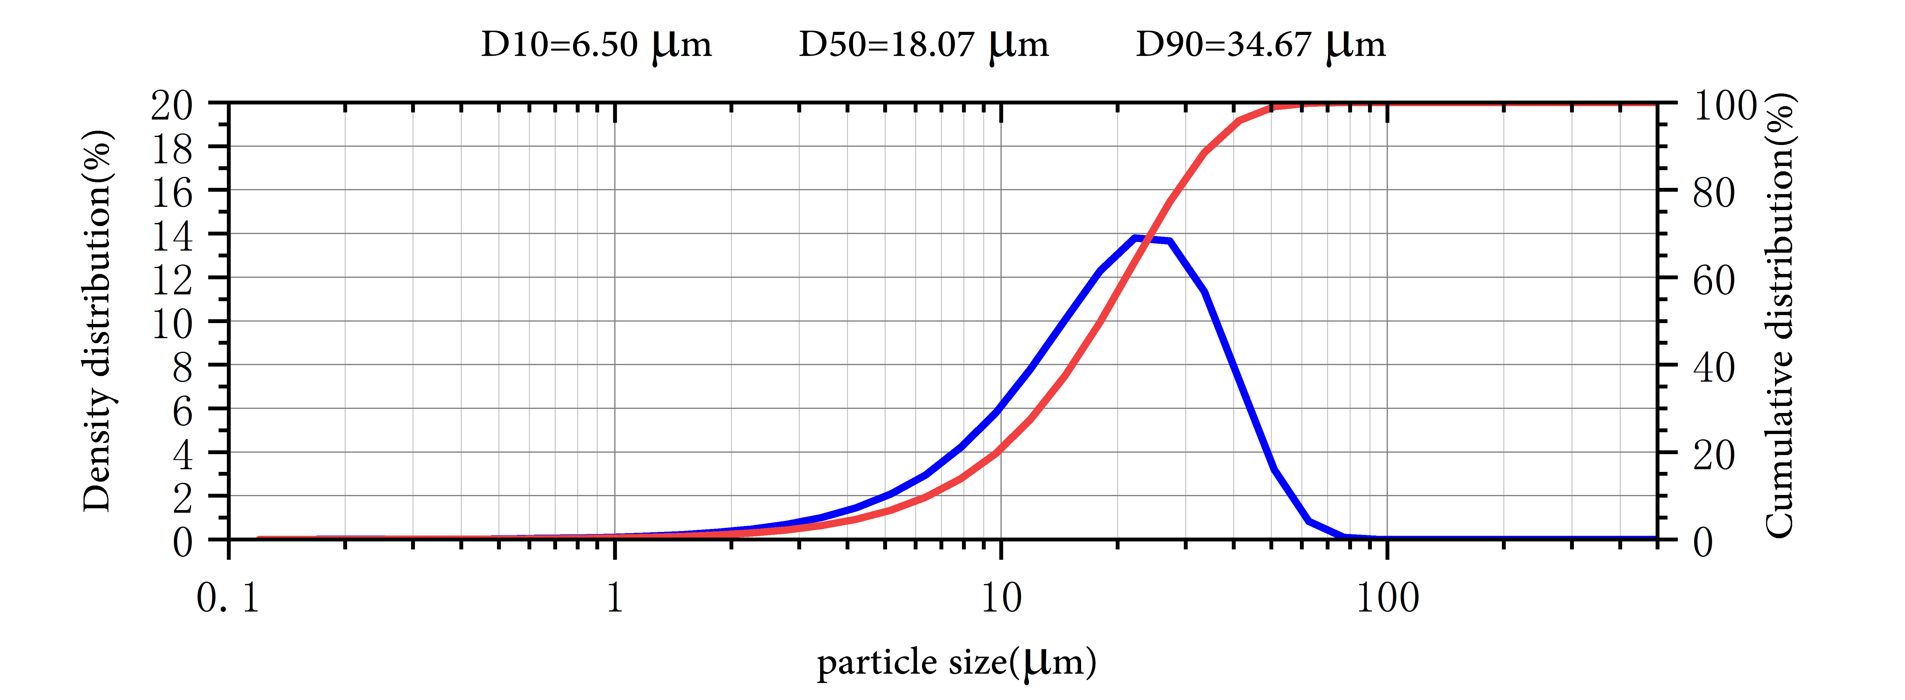

Application
Gadolinium as a metal or a salt absorbs neutrons and is, therefore, used sometimes for shielding in neutron radiography and in nuclear reactors, MRI(magnetic Resonance Imaging), superconductive materials and magnetic refrigerator. Gadolinium is also used in nuclear marine propulsion systems as a burnable poison. Gadolinium as a phosphor is also used in other imaging. In X-ray systems, gadolinium is contained in the phosphor layer, suspended in a polymer matrix at the detector. It is used for making Gadolinium Yttrium Garnet (Gd:Y3Al5O12); it has microwave applications and is used in fabrication of various optical components and as substrate material for magneto-optical films. Gadolinium Gallium Garnet (GGG, Gd3Ga5O12) was used for imitation diamonds and for computer bubble memory. It can also serve as an electrolyte in Solid Oxide Fuel Cells (SOFCs).
Package:
Vacuum pumping and argon protection, 500g or 1000g / bottle

