Molecular Formula: GdB₆
Purity: 99.9%
Specification:- 360 mesh / - 500 mesh
CAS:12008-06-9
EINECS No.:234-530-0

Gadolinium Boride (GdB₆)-Powder

Characteristic

Gadolinium Boride, also called Gadolinium Hexaboride, is one of the rare earth borides, the molecular formula is GdB₆. In the metallic compound GdB₆, gadolinium shows a very unusual magnetic behavior. GdB₆ crystallizes in a cubic CaB₆-type structure and orders antiferromagnetically at T_{N}=16 K. While no crystal field splitting is expected for the Gd³⁺ ground state, earlier studies showed deviations from the Curie-Weiss law of magnetic susceptibility far above T_{N} and a Schottky anomaly at 30 K in the specific heat measure-ments. The existence of short-range ordering above T_{N} to explain the anomalous magnetic behavior in GdB₆ Recent studies of the electrical resistivity and magnetic torque reveal the existence of a second magnetic transition around 10 K in zero magnetic field and a more complicated magnetic field-versus-temperature phase diagram.

Molar mass： 222.11 g/mol
Density： 5.27 g/cm³
Melting point： 2,100 °C
Solubility in water：insoluble
Crystal structure：Cubic

Chemical Composition
 | Major constituent |  | Impurity(≤)
Item | B | Gd | Fe | C | Mg | Si | Ca | Mn | Cu | Cr
Content(%) | 28.82 | 70.36 | 0.032 | 0.22 | 0.0008 | 0.0076 | 0.0073 | 0.00064 | 0.00078 | 0.0008

Granularity of materials -360 mesh
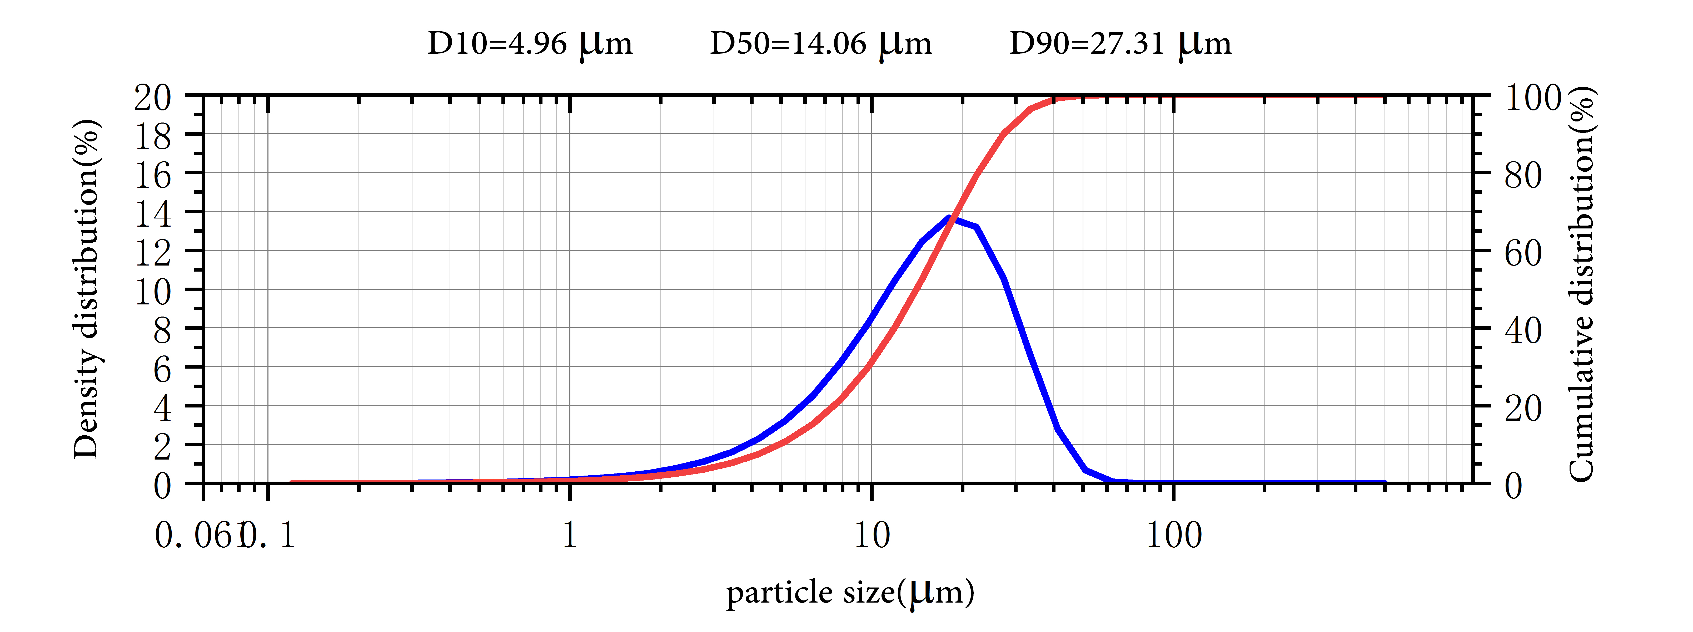

Application
Gadolinium hexaboride (GdB6) is classified in the groups of materials of superior properties attracting the attention of many scientist and technologist recently. Its unique features such as high mechanical strength and thermal stabilities, low work function, high melting points, and low volatility at high temperatures make them potential candidates for the advanced technological applications. Its unique electromagnetic properties have been drawing continued interest for a variety of engineering applications.

It is also used in radar, aerospace, consumer electronics, instrumentation, nuclear power, and other fields. Chemical intermediates, electronic materials, optical materials, ceramic materials, thermal barrier materials, coating materials, catalytic materials.

Gadolinium Boride Synonyms
Gadolinium hexaboride

Package:
Vacuum pumping and argon protection, 500g or 1000g / bottle

