Molecular Formula: YbB₆
Purity: 99.9%
Specification:- 360 mesh / - 500 mesh
CAS:12008-33-2
EINECS No.:234-540-5

Ytterbium Boride (YbB₆)-Powder

Characteristic

Ytterbium Boride Powder, also called Ytterbium Hexaboride, is one of the rare earth borides, the molecular formula is YbB₆. Ytterbium hexaboride is black crystalline powder. Among all REB₆, YbB₆ is especially attractive for its relatively low density, high mechanical strength, and high melting point characteristics. The crystalline form of YbB₆ has cubic Pm-3m space group symmetry like most of the rare-earth hexaborides (REB₆), resembling the crystal structure of CsCl. Rare-earth ion and octahedral B6 occupy Cs site and Cl site respectively, and the octahedral B6 cluster links to each other by strong covalent bonds providing high hardness characteristics.
YbB₆ is traditionally synthesized through mechano-chemical processes, high temperature sintering methods, vacuum calcination, and combustion synthesis.

Molar mass：237.96 g/mol
Solubility in water：insoluble
Crystal structure：Cubic

Chemical Composition
 | Major constituent |  | Impurity(≤)
Item | B | Yb | Fe | C | Mg | Si | Ca | Mn | Cu | Cr
Content(%) | 25.77 | 73.85 | 0.028 | 0.19 | 0.00029 | 0.0045 | 0.0079 | 0.0007 | 0.00030 | 0.0006

Granularity of materials -360 mesh
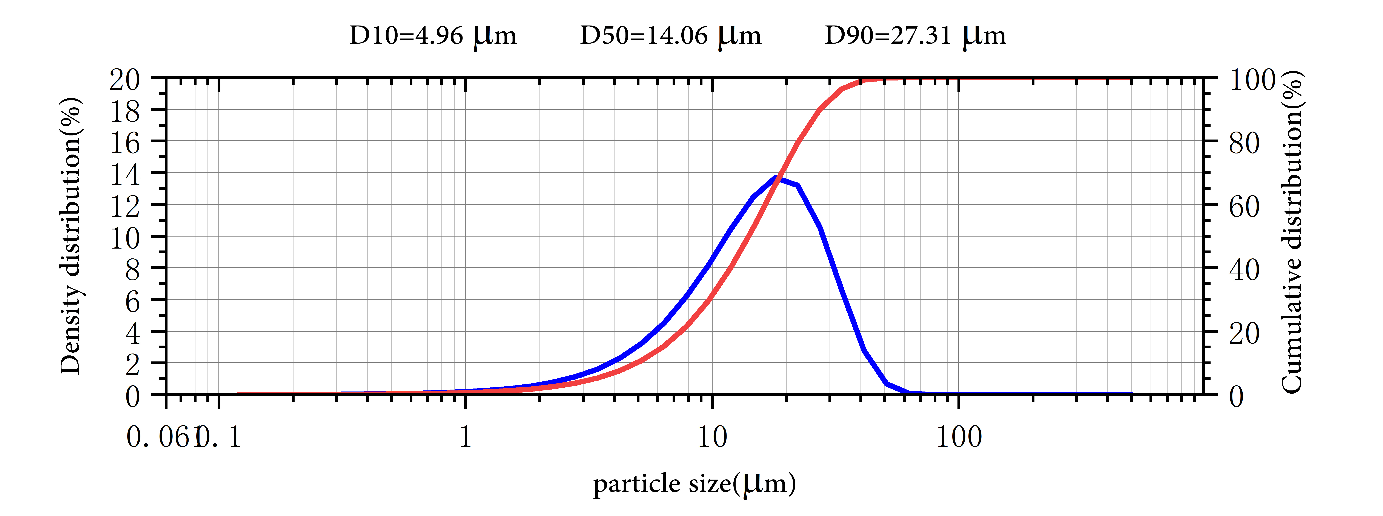

Application
Rare earth and alkaline earth hexaborides have potential uses in a variety of engineering applications because of their unique electrochemical and magnetic properties.
Ytterbium hexaboride (YbB₆) has a unique conductive surface and has broad application prospects in engineering applications. Its unique properties also enhance the possibility of selective adsorption of small molecules to the YbB6 surface. Therefore, YbB6 is also a potential sensing material.

Ytterbium Boride Synonyms
Ytterbium hexaboride

Package:
Vacuum pumping and argon protection, 500g or 1000g / bottle

