Molecular Formula: LaB₆
Purity: 99.5%
Specification:- 360 mesh / - 500 mesh
CAS:12008-21-8
EINECS No.:234-531-6

Lanthanum boride (LaB₆)-Powder

Characteristic

Lanthanum Boride, also called Lanthanum Hexaboride or LaB6, is an inorganic chemical and refractory ceramic material. It has a high melting point of 2210 °C and is insoluble in water and hydrochloric acid. It is extremely hard, with a Mohs hardness of 9.5. It has a low work function and one of the highest electron emissivities known, and is stable in vacuum. Stoichiometric samples are colored intense purple-violet, while boron-rich ones (above LaB_{6.07}) are blue. Ion bombardment changes its color from purple to emerald green. LaB6 is a superconductor with a relatively low transition temperature of 0.45 K.

Molar mass： 203.78 g/mol
Appearance： intense purple violet
Density： 4.72 g/cm³
Melting point： 2,210 °C (4,010 °F; 2,480 K)
Solubility in water：insoluble
Crystal structure：Cubic

Chemical Composition
 | Major constituent |  | Impurity(≤)
Item | B | La | Fe | W | C | Mg | Si | Ca | Mn | Cu | Cr
Content(%) | 31.15 | 68.56 | 0.0185 | 0.0088 | 0.047 | 0.00013 | 0.0018 | 0.0077 | 0.0003 | 0.0004 | 0.0002

Granularity of materials -360 mesh
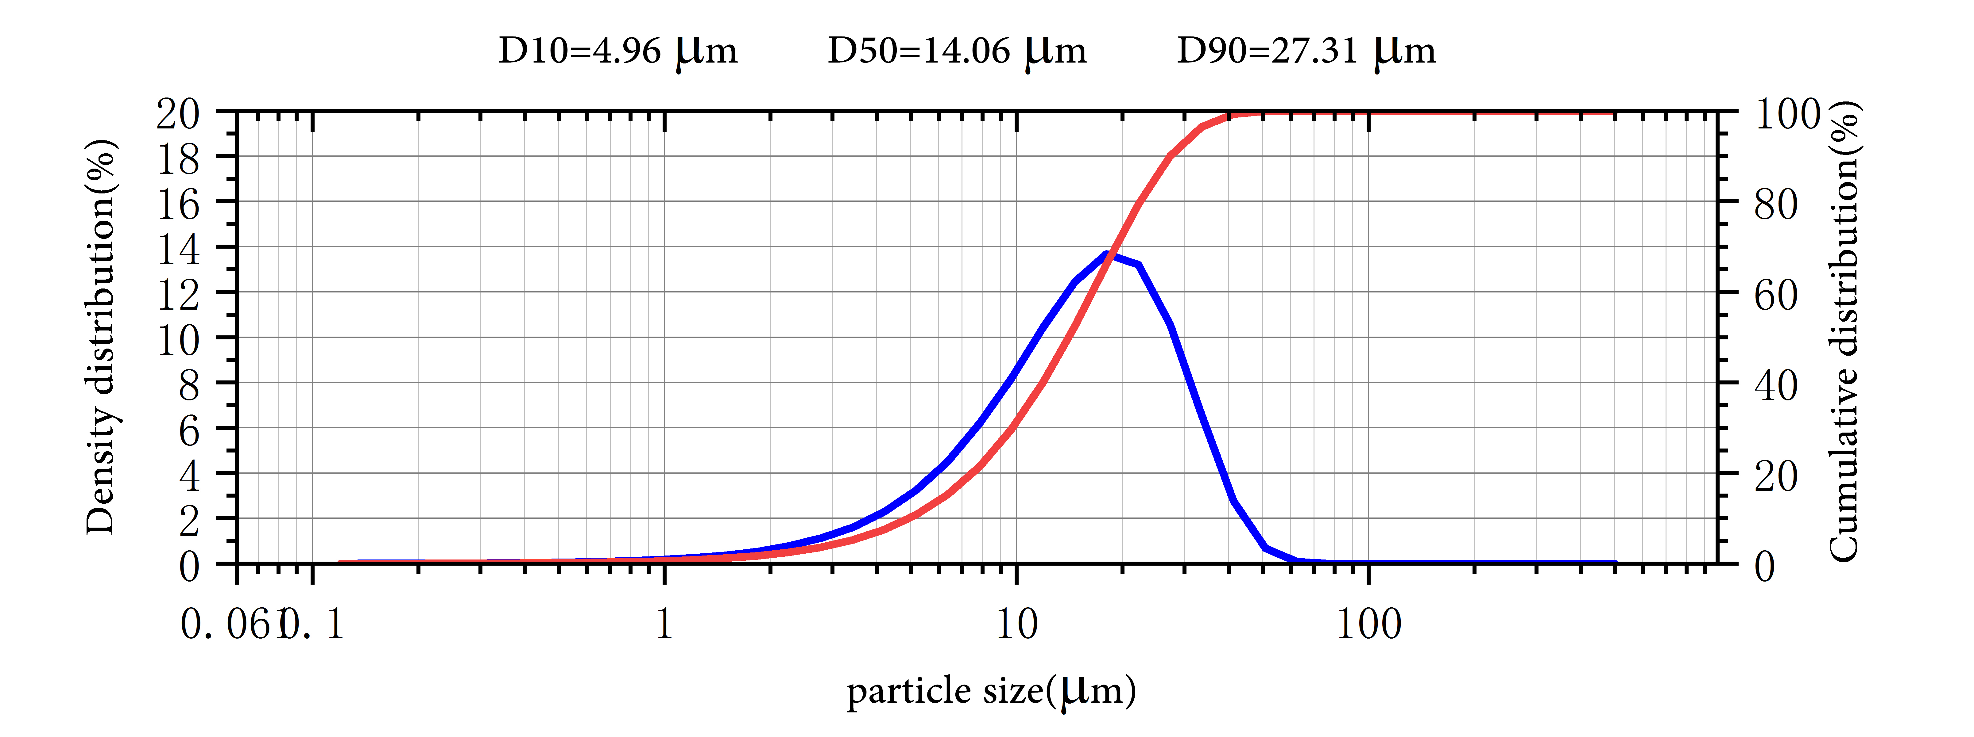

Application
The principal use of lanthanum hexaboride is in hot cathodes, either as a single crystal or as a coating deposited by physical vapor deposition. Hexaborides, such as lanthanum hexaboride (LaB6) and cerium hexaboride (CeB6), have low work functions, around 2.5 eV. They are also somewhat resistant to cathode poisoning. Cerium hexaboride cathodes have a lower evaporation rate at 1700 K than lanthanum hexaboride, but they become equal at temperatures above 1850 K. Cerium hexaboride cathodes have one and half the lifetime of lanthanum hexaboride, due to the former's higher resistance to carbon contamination. Hexaboride cathodes are about ten times "brighter" than tungsten cathodes, and have 10–15 times longer lifetime. Devices and techniques in which hexaboride cathodes are used include electron microscopes, microwave tubes, electron lithography, electron beam welding, X-ray tubes, and free electron lasers. Lanthanum hexaboride slowly evaporates from the heated cathodes and forms deposits on the Wehnelt cylinders and apertures.
LaB6 is also used as a size/strain standard in X-ray powder diffraction to calibrate instrumental broadening of diffraction peaks.

Lanthanum Boride Synonyms
Lanthanum hexaboride

Package:
Vacuum pumping and argon protection, 500g or 1000g / bottle

