Molecular Formula: Er
Purity:99.9%
Specification:- 100 mesh / - 200 mesh
CAS:7440-52-0
EINECS No.:231-160-1
Hazardous Class:Class 4.1
UN No.:UN3089

Erbium Metal (Er)-Powder

Characteristic

Erbium is a chemical element with the symbol Er and atomic number 68. A silvery-white solid metal when artificially isolated, natural erbium is always found in chemical combination with other elements. It is a lanthanide, a rare-earth element, originally found in the gadolinite mine in Ytterby, Sweden, which is the source of the element's name. Erbium is slowly oxidized by air and water at room temperature.

Appearance：Powder
Melting point：1802 K (1529 °C, 2784 °F)
Boiling point：3141 K (2868 °C, 5194 °F)
Density (near r.t.)：9.066 g/cm³
when liquid (at m.p.)：8.86 g/cm³
Heat of fusion：19.90 kJ/mol
Heat of vaporization：280 kJ/mol
Molar heat capacity：28.12 J/(mol·K)

Chemical Composition

Rare Earth Impurity(≤) |  |  |  | Er/RE |  | ≥99.9%
Item | La/RE | Ce/RE | Pr/RE | Nd/RE | Sm/RE | Eu/RE | Gd/RE
Content(%) | 0.0020 | 0.0050 | 0.0050 | 0.0050 | 0.0020 | 0.0020 | 0.0020
Item | Tb/RE | Dy/RE | Ho/RE | Tm/RE | Yb/RE | Lu/RE | Y/RE
Content(%) | 0.0020 | 0.0020 | 0.0020 | 0.0020 | 0.0020 | 0.0200 | 0.0450
Non-Rare Earth Impurity(≤) |  |  |  | RE |  | ≥99%
Item | Al | Fe | Ca | Si | Mg | C | Ni
Content(%) | 0.0100 | 0.0570 | 0.0031 | 0.0100 | 0.0012 | 0.0100 | 0.0571

Granularity of materials - 200 mesh
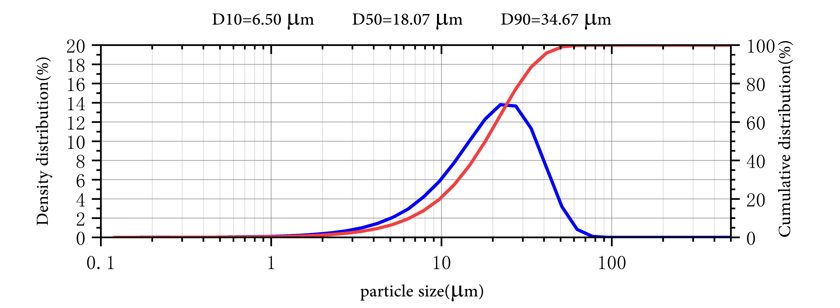

Application

Erbium finds little use as a metal because it slowly tarnishes in air and is attacked by water.
When alloyed with metals such as vanadium, erbium lowers their hardness and improves their workability.
Erbium oxide is occasionally used in infrared absorbing glass, for example safety glasses for welders and metal workers. When erbium is added to glass it gives the glass a pink tinge. It is used to give colour to some sunglasses and imitation gems.
Broadband signals, carried by fibre optic cables, are amplified by including erbium in the glass fibre.

Package:
Vacuum pumping and argon protection, 500g or 1000g / bottle

