Molecular Formula: CeH_{2~3}
Purity: 99.5%
Specification:- 100 mesh / - 200 mesh
CAS:13864-02-3
EINECS No.:237-608-2

Cerium hydride(CeH_{2~3})-Powder

Characteristic
Cerium metal (γ-phase) at room temperature possesses the face-centered cubic (fcc) structure. Upon incorporation of hydrogen and beyond its solubility limit, CeH₂ is first formed as the hydride H− ions occupy the tetrahedral sites in the fluorite fcc structure. Increasing hydrogen stoichiometry leads to a series of well-defined H-stoichiometry and temperature dependent structures. As the additional H− ions occupy the octahedral sites, the highest stoichiometry of CeH₃ is achieved, possessing a BiF₃-type structure.

Appearance：Powder
Molecular weight：143.14 g/mol
Density (near r.t.)：5.5 g/cm³

Chemical Composition
Rare Earth Impurity(≤) |  |  | Ce/RE |  | ≥99.5%
Item | La/RE | Pr/RE | Nd/RE | Sm/RE | Y/RE
Content(%) | 0.052 | 0.074 | 0.017 | 0.010 | 0.010
Non-Rare Earth Impurity(≤) |  |  | RE |  | ≥99%
Item | Fe | Si | Ca | Mg | Al | C
Content(%) | 0.087 | 0.026 | 0.012 | 0.018 | 0.013 | 0.027

Granularity of materials- 200 mesh
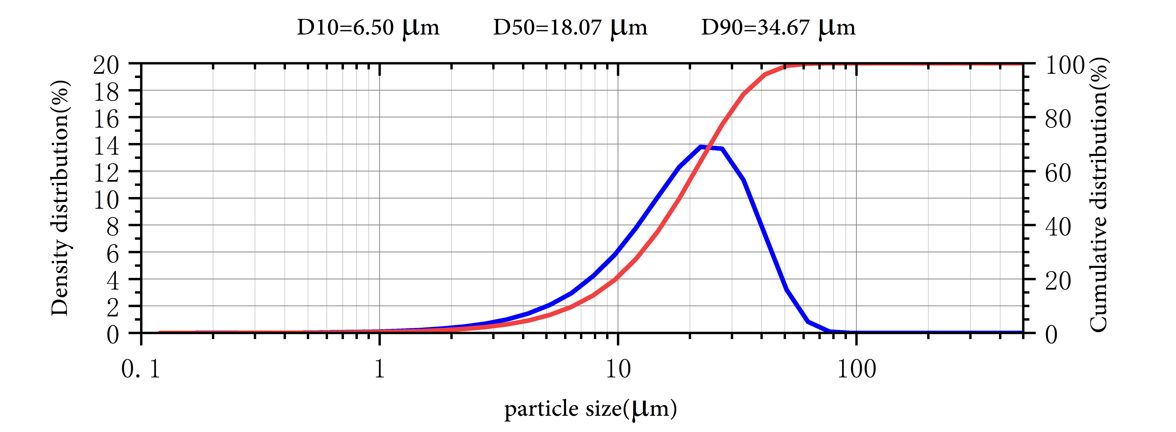

Application
Among many metal hydrides, rare earth metal hydrides represented by cerium hydride are favored by researchers in the field of energetic materials due to their high chemical potential and reactivity.
Cerium hydride is also widely used as a hydrogen storage material.
Package:
Vacuum pumping and argon protection, 500g or 1000g / bottle

