Molecular Formula: Ho
Purity:99.9%
Specification:- 100 mesh / - 200 mesh
CAS:7440-60-0
EINECS No.:231-169-0
Hazardous Class:Class 4.1
UN No.:UN3089

Holmium Metal (Ho)-Powder

Characteristic

Holmium is a chemical element with the symbol Ho and atomic number 67. It is a rare-earth element and the eleventh member of the lanthanide series. It is a relatively soft, silvery, fairly corrosion-resistant and malleable metal. Like a lot of other lanthanides, holmium is too reactive to be found in native form, as pure holmium slowly forms a yellowish oxide coating when exposed to air. When isolated, holmium is relatively stable in dry air at room temperature. However, it reacts with water and corrodes readily, and also burns in air when heated.

Appearance：Powder
Melting point：1734 K (1461 °C, 2662 °F)
Boiling point：2873 K (2600 °C, 4712 °F)
Density (near r.t.)：8.79 g/cm³
when liquid (at m.p.)：8.34 g/cm³
Heat of fusion：17.0 kJ/mol
Heat of vaporization：251 kJ/mol
Molar heat capacity：27.15 J/(mol·K)

Chemical Composition

Rare Earth Impurity(≤) |  |  |  | Ho/RE |  | ≥99.9%
Item | La/RE | Ce/RE | Pr/RE | Nd/RE | Sm/RE | Eu/RE | Gd/RE
Content(%) | 0.0005 | 0.0001 | 0.0010 | 0.0008 | 0.0001 | 0.0001 | 0.0001
Item | Tb/RE | Dy/RE | Er/RE | Tm/RE | Yb/RE | Lu/RE | Y/RE
Content(%) | 0.0085 | 0.0120 | 0.0087 | 0.0062 | 0.0095 | 0.0011 | 0.0120
Non-Rare Earth Impurity(≤) |  |  |  | RE |  | ≥99%
Item | Al | Fe | Ca | Si | Mg | C | O
Content(%) | 0.0190 | 0.1000 | 0.0120 | 0.0250 | 0.0014 | 0.0110 | 0.0342

Granularity of materials - 200 mesh
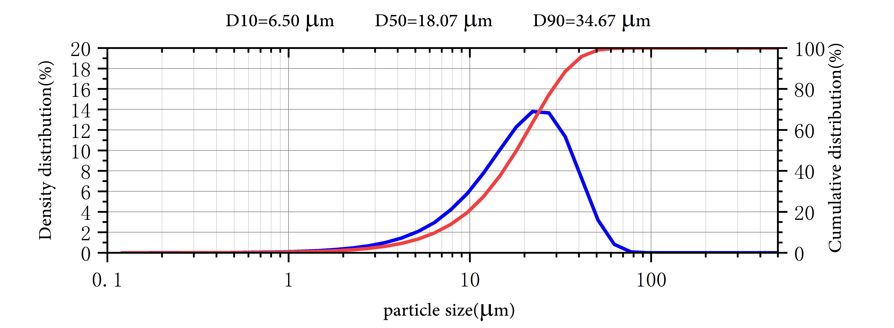
Application
Holmium has the highest magnetic permeability of any element and therefore is used for the polepieces of the strongest static magnets. Because holmium strongly absorbs neutrons, it is also used as a burnable poison in nuclear reactors.Holmium-doped fibers can be used to make fiber lasers, fiber amplifiers, fiber sensors, etc.

Package:
Vacuum pumping and argon protection, 500g or 1000g / bottle

