Molecular Formula: Nd
Purity:99.9%
Specification:- 100 mesh / - 200 mesh
CAS:7440-00-8
EINECS No.:231-109-3
Hazardous Class:Class 4.1
UN No.:UN3089

Neodymium Metal (Nd)-Powder

Characteristic

Neodymium is a chemical element with the symbol Nd and atomic number 60. It is the fourth member of the lanthanide series and is considered to be one of the rare-earth metals. It is a hard, slightly malleable, silvery metal that quickly tarnishes in air and moisture. When oxidized, neodymium reacts quickly to produce pink, purple/blue and yellow compounds in the +2, +3 and +4 oxidation states. It is generally regarded as having one of the most complex spectra of the elements.

Appearance：Powder
Melting point： 1297 K (1024 °C, 1875 °F)
Boiling point： 3347 K (3074 °C, 5565 °F)
Density (near r.t.)： 7.01 g/cm³
when liquid (at m.p.)： 6.12 g/cm³
Heat of fusion： 7.14 kJ/mol
Heat of vaporization： 273 kJ/mol
Molar heat capacity： 27.45 J/(mol·K)

Chemical Composition

Rare Earth Impurity(≤) |  |  |  | Nd/RE |  | ≥99.5%
Item | La/RE | Ce/RE | Pr/RE | Sm/RE | Y/RE
Content(%) | 0.012 | 0.020 | 0.020 | 0.010 | 0.001
Non-Rare Earth Impurity(≤) |  |  |  | RE |  | ≥99%
Item | Fe | Si | Ca | Mg | Al | C | Mo
Content(%) | 0.241 | 0.010 | 0.010 | 0.010 | 0.010 | 0.039 | 0.033

Granularity of materials - 200 mesh
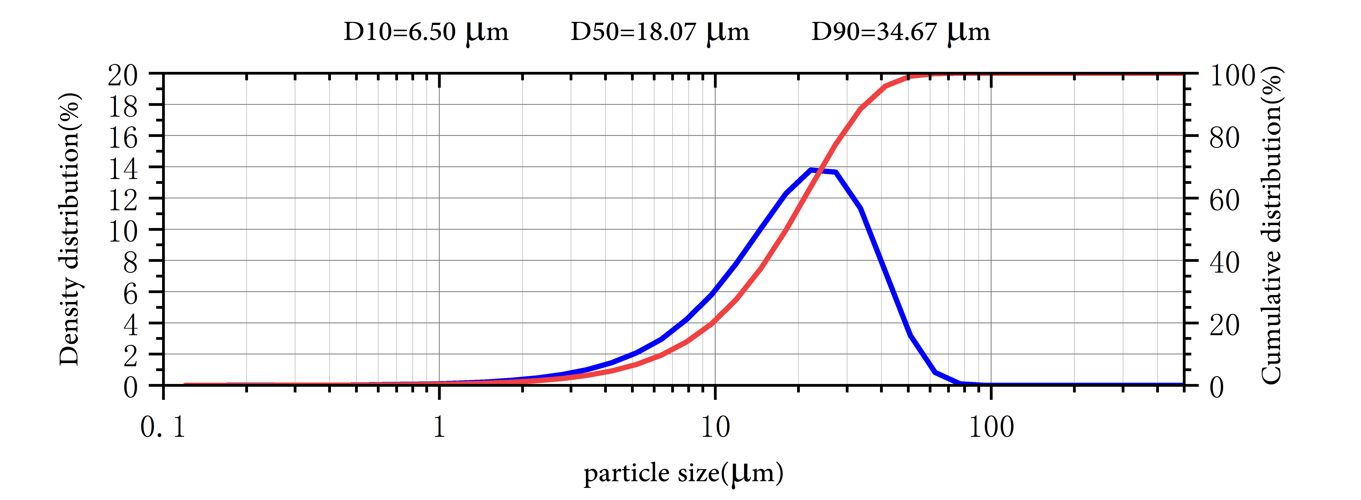

Application

The most important use for neodymium is in an alloy with iron and boron to make very strong permanent magnets. This discovery, in 1983, made it possible to miniaturise many electronic devices, including mobile phones, microphones, loudspeakers and electronic musical instruments. These magnets are also used in car windscreen wipers and wind turbines.

Neodymium is a component, along with praseodymium, of didymium glass. This is a special glass for goggles used during glass blowing and welding. The element colours glass delicate shades of violet, wine-red and grey. Neodymium is also used in the glass for tanning booths, since it transmits the tanning UV rays but not the heating infrared rays.

Neodymium glass is used to make lasers. These are used as laser pointers, as well as in eye surgery, cosmetic surgery and for the treatment of skin cancers.

Neodymium oxide and nitrate are used as catalysts in polymerisation reactions.

Package:
Vacuum pumping and argon protection, 500g or 1000g / bottle

